

Name/ID : ABDELKAREEM YOUSEF MAMDOH SOUBAR/19110022

Subject : **Network Security**

Assignment Title: **JNR network security**

Submission Date : 19/6/ 2023

Part 1:

Investigating the Purpose and Requirements of the Secure Network

The goal of the secure network in this situation is to establish a strong and protected infrastructure that guarantees the confidentiality, integrity, and availability of JNR's data and services. It should enable secure communication between the headquarters in Amman and the remote offices in Saudi Arabia, Turkey, Aqaba, and Irbid. The requirements for the secure network are as follows:

a. Secure Access: Employees must be able to securely access the Employee Information System (EIS) through a secure website using HTTPS and a Fully Qualified Domain Name (FQDN).

b. Site-to-Site Connectivity:(from saudi and terky to HQ amman) The headquarters and remote offices should be connected through VPN/IPsec site-to-site connections to ensure secure communication and data transfer.

c. Segmentation: The network should be divided into VLANs and subnets to ensure proper isolation and security between different departments and locations.

d. Proper Routing: The network should support dynamic routing protocols to efficiently route traffic between different locations without relying on static routing.

Determining Network Hardware and Software:

To meet these requirements, the following network hardware and software can be used:

a. Network Hardware:

- Routers: Cisco ISR (Integrated Services Routers) provide advanced security features and routing capabilities.

- LAN Switches: Cisco Catalyst switches support VLANs, port security, and access control features.

- Firewalls: Cisco ASA (Adaptive Security Appliance) offers robust firewall functionality and secure remote access.

- Network Gateways: These devices connect the network with external networks.

b. Network Software:

- Router and Switch Operating Systems: Cisco IOS (Internetwork Operating System) provides a wide range of security features.

- Firewall Software: Cisco ASA software allows for firewall configuration and management.

- VPN Software: IPSec VPN software is used to establish secure site-to-site connections.

- SSL/TLS Libraries: These libraries enable the implementation of secure HTTPS communication.

- DHCP and DNS Server Software: DHCP servers manage IP addressing, while DNS servers provide name resolution services.

Designing and Implementing a Secure Network Prototype:

Using the Packet Tracer simulator, a secure network prototype can be designed and implemented based on the given scenario. The design should involve the following steps:

a. Segmentation: Create VLANs and subnets for each office and the headquarters, ensuring that each station has a unique IP subnet.

b. Device Configuration: Configure routers, switches, firewalls, and gateways based on the network topology, assigning appropriate IP addresses and enabling necessary protocols.

c. VPN/IPsec Configuration: Implement site-to-site VPN/IPsec connections between the headquarters and remote offices to ensure secure communication.

d. DHCP and DNS Configuration: Configure DHCP servers to assign dynamic IP addresses to devices, and DNS servers to provide name resolution services.

Configuring Network Security Measures:

To enhance network security, the following measures can be implemented:

a. Firewalls: Configure the ASA firewall to enforce access control rules, allowing only necessary services and blocking unauthorized access.

b. Routers and Switches: Set strong passwords, enable SSH for secure remote access, disable unused ports, and implement port security with a maximum MAC address limit to prevent unauthorized connections.

c. Gateways: Assign static IP addresses to gateway devices for reliable connectivity and secure management.

d. User Authentication: Enforce password policies for user accounts and implement Local AAA Authentication for VTY Lines on the Irbid router using a specific username and password.

e. Encryption and Secure Protocols: Utilize SSL/TLS for secure HTTPS communication, IPSec VPN for encrypted site-to-site connections, and SSH for secure remote access.

f. Access Control: Configure access control rules to allow appropriate access to servers and services based on the specified requirements.

g. DHCP and DNS Security: Implement DHCP security measures to prevent

spoofing and starvation attacks, and configure DNS security features to protect against DNS-related threats.

The chosen network security configuration is based on industry best practices and standards. It adopts a layered approach to network security, incorporating firewalls for perimeter security, encryption and authentication mechanisms for secure access, and proper configuration of network devices to ensure secure operations and protect against potential threats.

Categories of Devices for Ensuring Network Security:

There are various categories of devices used to ensure network security. These devices play critical roles in protecting networks from unauthorized access, data breaches, and other security threats. Some of the commonly employed devices include:

a. Firewalls: Firewalls act as the first line of defense for network security. They monitor and control incoming and outgoing network traffic based on predetermined security rules, helping to prevent unauthorized access.

b. Intrusion Detection Systems (IDS) and Intrusion Prevention Systems (IPS): IDSs detect and alert administrators about potential security breaches or unauthorized activities on the network. IPSs not only detect but also actively prevent such incidents by blocking malicious traffic.

c. Virtual Private Network (VPN) Concentrators: VPN concentrators facilitate secure remote access to private networks over public networks like the internet. They establish encrypted connections, ensuring data confidentiality and integrity.

d. Proxy Servers: Proxy servers act as intermediaries between client devices and external networks. They can enhance security by filtering and scanning network traffic, blocking malicious content or unauthorized access attempts.

e. Network Access Control (NAC) Systems: NAC systems enforce policies that control access to network resources. They authenticate and authorize devices and users, ensuring only authorized entities can connect to the network.

f. Unified Threat Management (UTM) Appliances: UTM appliances combine multiple security functions into a single device, including firewall, antivirus, intrusion detection and prevention, content filtering, and virtual private networking capabilities.

g. Secure Web Gateways (SWG): SWGs protect against web-based threats by filtering and monitoring web traffic, blocking malicious websites, and preventing data loss through web channels.

h. Secure Email Gateways (SEG): SEGs analyze incoming and outgoing email traffic, scanning for malware, spam, and other email-borne threats, ensuring secure email communication.

Network Security Protocols and Cryptographic Methodologies:

Network security protocols and cryptographic methodologies play a crucial role in securing network communications. They provide mechanisms for authentication, confidentiality, integrity, and secure key exchange. Some significant network security protocols and cryptographic methodologies include:

a. Secure Socket Layer/Transport Layer Security (SSL/TLS): SSL/TLS protocols provide secure communication over the internet. They encrypt data during transmission, ensuring confidentiality and integrity. SSL/TLS also authenticates the identity of servers through digital certificates.

b. Internet Protocol Security (IPsec): IPsec is a protocol suite that provides secure IP communications. It offers authentication, integrity, and confidentiality for IP packets, enabling secure VPN connections and network-level security.

c. Secure Shell (SSH): SSH provides secure remote login and file transfer capabilities. It encrypts the entire session, preventing eavesdropping and unauthorized access.

d. Pretty Good Privacy (PGP) and GNU Privacy Guard (GPG): PGP and GPG are widely used for secure email communication. They employ public-key cryptography to provide confidentiality, integrity, and authentication of email messages.

e. Diffie-Hellman (DH) Key Exchange: DH is a cryptographic algorithm used for secure key exchange between two parties over an insecure channel. It allows secure communication without requiring pre-shared keys.

f. Advanced Encryption Standard (AES): AES is a widely used symmetric encryption algorithm. It ensures the confidentiality and integrity of data by encrypting and decrypting information using a shared secret key.

g. Secure Hash Algorithms (SHA): SHA algorithms generate fixed-size hash values to verify data integrity. They are commonly used for password storage, digital signatures, and integrity checking.

Comparisons and Contrasts between Network Security Protocols:

Several network security protocols have been developed to address specific security requirements. Here are a few comparisons and contrasts between significant network security protocols:

a. SSL/TLS vs. IPsec: Both SSL/TLS and IPsec provide secure communication, but they operate at different layers of the network stack. SSL/TLS is primarily used for securing web-based communication, while IPsec operates at the IP layer, securing network-level communication. SSL/TLS is commonly used for securing e-commerce transactions, while IPsec is often used for site-to-site or remote access VPNs.

b. SSH vs. SSL/TLS: SSH and SSL/TLS both provide secure communication, but they serve different purposes. SSH is primarily used for secure remote access and file transfer, while SSL/TLS is used for securing web communication. SSH is typically used for command-line access to remote systems, while SSL/TLS secures web browsers and servers.

c. PGP/GPG vs. S/MIME: Both PGP/GPG and S/MIME are cryptographic standards used for securing email communication. PGP/GPG use a web of trust model, where users sign each other's keys, while S/MIME relies on a centralized certificate authority model. PGP/GPG is often preferred for secure communication among individuals, while S/MIME is commonly used in corporate environments.

d. IPsec vs. SSL/TLS: IPsec and SSL/TLS both provide secure communication, but they differ in their deployment scenarios. IPsec is typically used for securing site-to-site VPNs or remote access VPNs, while SSL/TLS is commonly used for securing web-based communication.

Importance of Network Security to an Organization:

Network security is of paramount importance to organizations due to several reasons:

a. Data Protection: Network security safeguards sensitive data from unauthorized access, ensuring the confidentiality, integrity, and availability of critical information. It helps prevent data breaches, financial losses, and reputational damage.

b. Regulatory Compliance: Many industries have stringent compliance requirements, such as the General Data Protection Regulation (GDPR) and the Payment Card Industry Data Security Standard (PCI DSS). Network security measures are essential for complying with these regulations and avoiding penalties.

c. Business Continuity: Network security measures help ensure the continuous operation of critical systems and services. Protection against cyber threats minimizes the risk of downtime, data loss, and disruption to business operations.

d. Customer Trust: Strong network security measures enhance customer trust and confidence. Organizations that prioritize security demonstrate their commitment to protecting customer data, leading to increased customer loyalty and positive brand reputation.

e. Intellectual Property Protection: Network security helps safeguard intellectual property, trade secrets, and proprietary information. Preventing unauthorized access to valuable assets is crucial for maintaining a competitive edge in the market.

f. Legal Liabilities: Inadequate network security can expose organizations to legal liabilities. If a security breach occurs due to negligence or non-compliance, organizations may face lawsuits, financial penalties, and damage to their reputation.

Network Hardware and Software Selection Justification:

Selecting appropriate network hardware and software is crucial for ensuring effective network security. The choice should align with the organization's security requirements, budget, scalability, and operational needs. Justifications for specific network hardware and software choices will depend on the organization's context and goals. However, some general considerations for decision-making include:

a. Firewall: Firewalls are essential for securing network perimeters and controlling traffic. Organizations should choose firewalls that offer robust security features, such as intrusion prevention, deep packet inspection, and application-layer filtering.

b. Intrusion Detection/Prevention Systems (IDS/IPS): IDS/IPS solutions should be selected based on the organization's network architecture, traffic volume, and required detection capabilities. Considerations include real-time monitoring, automatic threat response, and integration with other security systems.

c. VPN Concentrators: When choosing VPN concentrators, organizations should consider factors such as encryption strength, scalability, client compatibility, centralized management capabilities, and support for authentication mechanisms.

d. NAC Systems: NAC solutions should support the organization's desired authentication methods, integrate with existing network infrastructure, and provide granular access control policies. Compatibility with various endpoint devices and operating systems is also important.

e. UTM Appliances: UTM appliances should offer a comprehensive set of security features that align with the organization's needs, including firewall, antivirus, intrusion detection, web filtering, and VPN capabilities. Scalability, performance, and ease of management are also important factors.

f. SWGs and SEGs: Selection of SWGs and SEGs should consider their ability to analyze web and email traffic, block known and emerging threats, provide content filtering, support secure communications, and integrate with existing email and web infrastructure.

Ultimately, the choice of network hardware and software should be based on a comprehensive evaluation of security requirements, performance needs, compatibility with existing infrastructure, vendor reputation, and ongoing support and maintenance considerations.

Part 2:

Evaluation and Testing of Network Security

1. Creating a Test Plan:

To ensure the network's security, a comprehensive test plan should be developed. This plan will involve different testing methods to assess network security, identify vulnerabilities, and evaluate the effectiveness of security measures. The following testing methods can be included:

a. Penetration Testing: This involves conducting controlled attacks on the network to identify potential vulnerabilities and assess its resistance to hacking attempts. Penetration testers simulate real-world attacks to uncover any weaknesses that could be exploited by malicious actors.

b. Vulnerability Scanning: Automated tools can be used to scan the network for known vulnerabilities in software, configurations, and systems. The results of the scan provide valuable insights into areas that require attention and patching.

c. Password Strength Testing: Testing the strength of passwords is crucial to prevent unauthorized access. By attempting to crack passwords using brute-force or dictionary attacks, the effectiveness of password policies and the need for improvements can be determined.

d. Firewall Testing: Firewalls play a critical role in network security. Testing the effectiveness of the firewall involves verifying if it properly enforces access control rules and blocks unauthorized access attempts. Attempts to bypass or exploit the firewall's restrictions can help identify potential weaknesses.

e. Router and Switch Security Testing: Routers and switches are key components of a secure network. Evaluating their security configurations ensures that they are properly hardened and protected against common threats. Testing can include checking for default settings, weak authentication, and insecure protocols.

f. Access Control Testing: Access control mechanisms should be evaluated to ensure that only authorized individuals have appropriate access to sensitive resources and data. Testing can involve verifying the enforcement of user roles, permissions, and authentication mechanisms.

2. Comprehensive Testing:

The devised test plan should be implemented to perform thorough testing on all network devices, including firewalls, servers, routers, switches, gateways, and passwords. Each test should be executed meticulously, and the results should be recorded for analysis.

For example, during penetration testing, testers simulate various attack scenarios to uncover potential vulnerabilities. They may attempt to exploit known weaknesses, gain unauthorized access to systems, or extract sensitive information. The test results should document any successful breaches and the severity of the vulnerabilities.

Screenshots, scripts, and files should be collected throughout the testing process to provide evidence and aid in the analysis of the results.

This is the running configuration from Turkey router to Amman router. Pinging to the server is working in a correct manner.

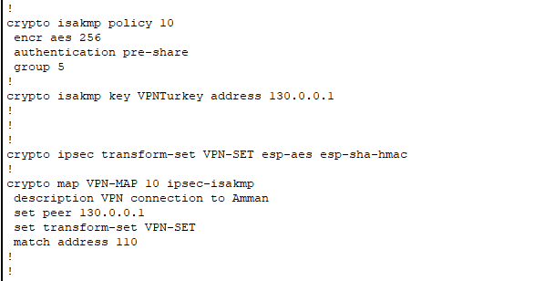

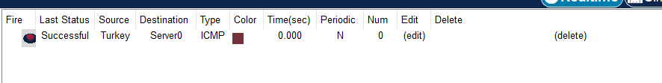

This is the running configuration from Saudi Arabiarouter to Amman router. Pinging to the server is working in a correct manner.

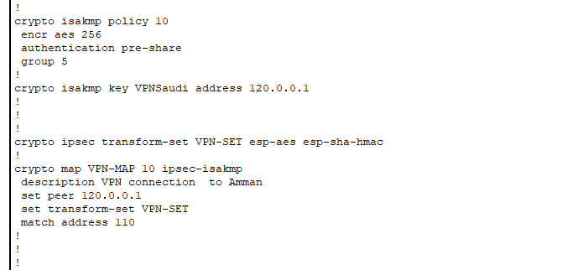

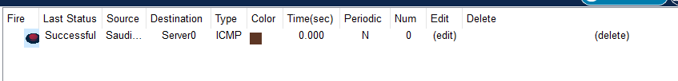

All of the routers and switches are configured with the enable secret command, which provides an encrypted password for accessing the privileged access mode.

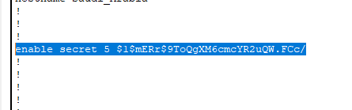

Enabling the ssh protocol on the Saudi router, of course it is configured on other routers.

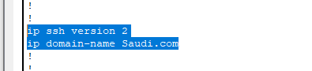

Any unused ports are shut off, this is the Turkey switch for example.

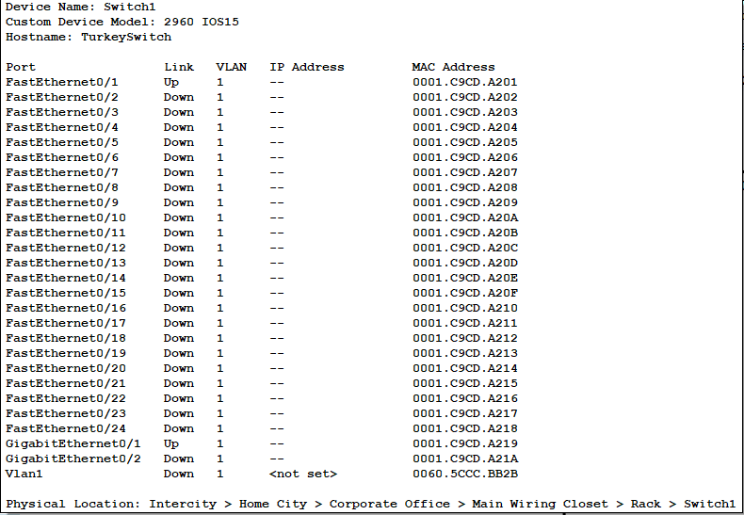

Configuring the port security, dhcp snooping maximum limit is 5 as well as the MAC addres sticky. It is assigns the port with a certain MAC address, which is dynamic. Its function is that if the port detects two different MAC addresses, it would restrict the port.

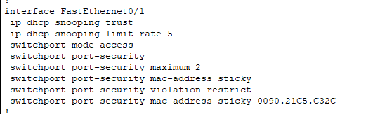

I used the OSPF routing protocol, which is a dynamic routing protocol. Turkey OSPF 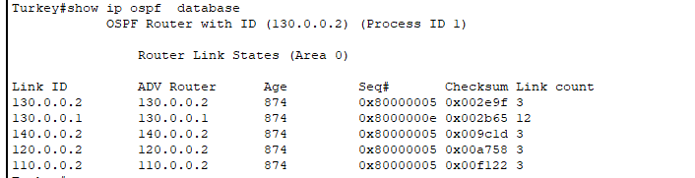

Amman OSPF

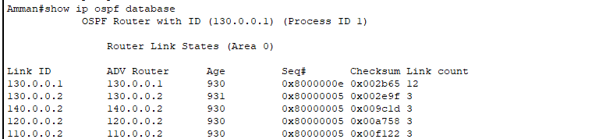

Successful result!



Accessing HTTPS through the Turkey PC

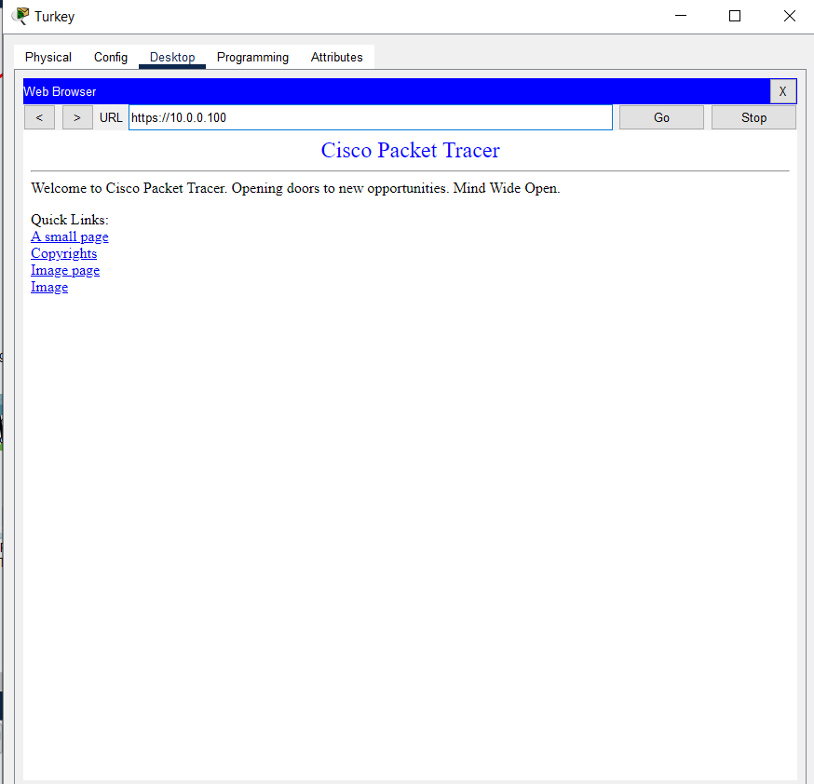

SMTP and POP3 functions correctly

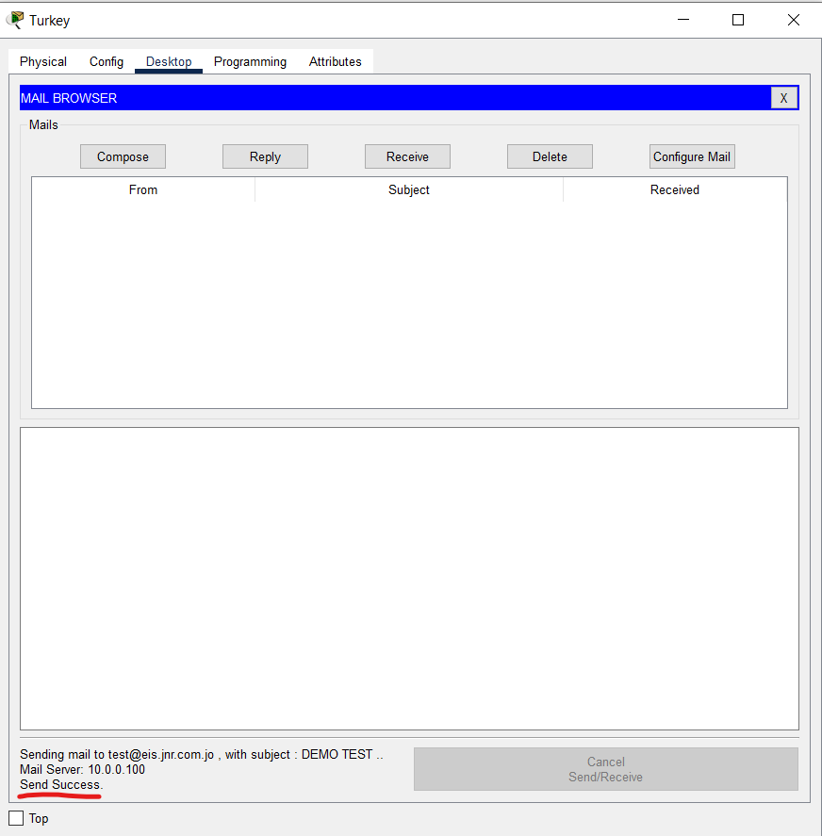

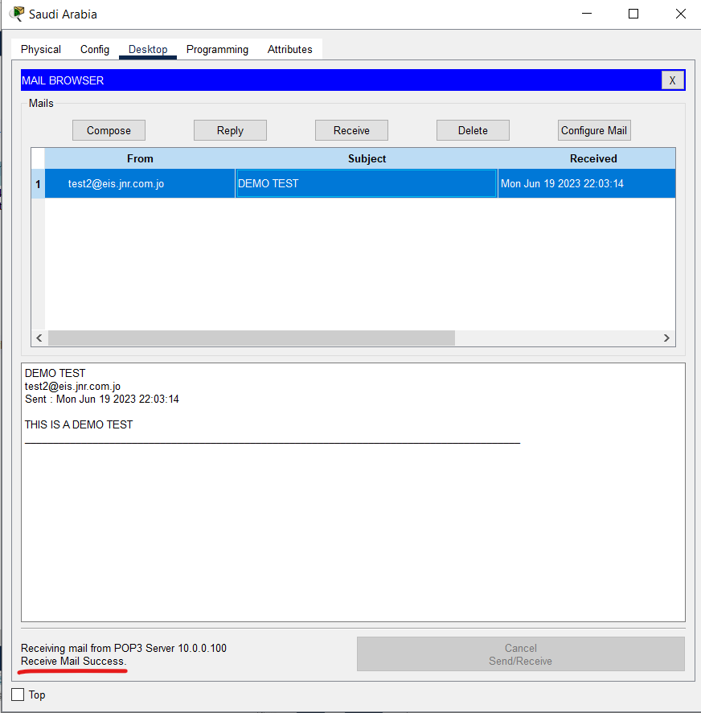

DNS HTTPS working correctly

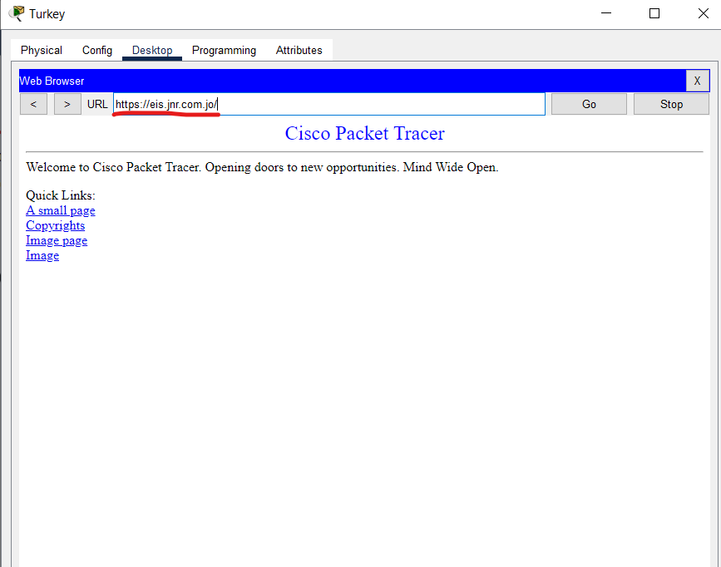

The DNS for the HTTP is not working, which should be like that. This is because Turkey is not allowed to access the HTTP server.

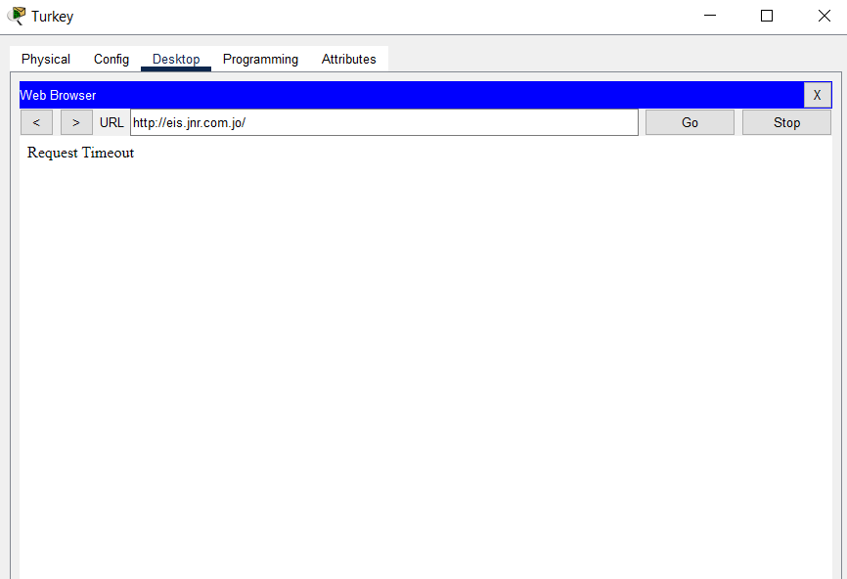

FTP ACL working for Amman HQ

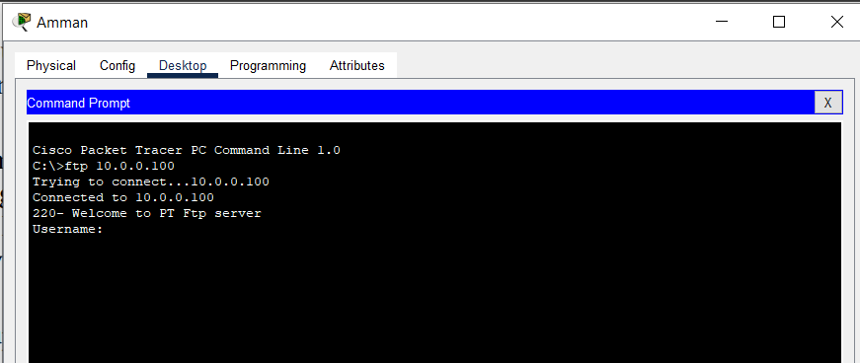

FTP ACL working for Turkey, which is denied access for the FTP server.

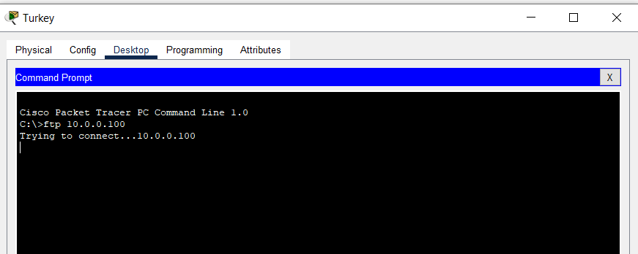

DHCP Server working for Amman HQ

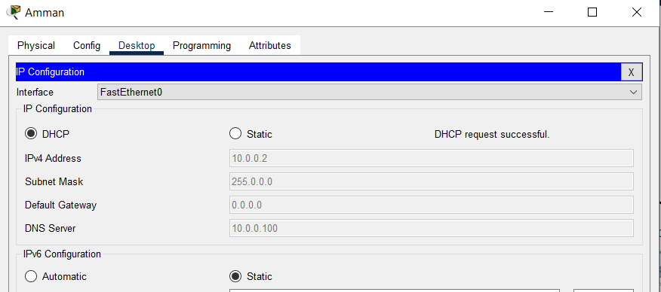

DHCP Server not working for the Turkey PC, which is configured through ACL

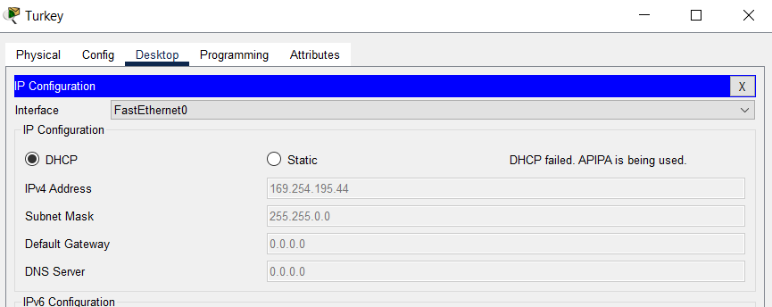

Amman HQ can access HTTP

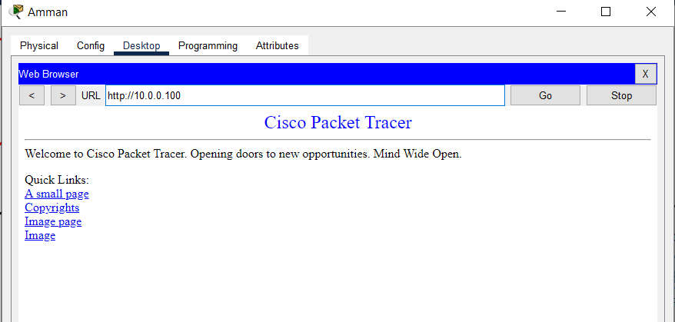

Turkey trying to access HTTP, which is timed out. It is a correct output because it is configured through the ACL

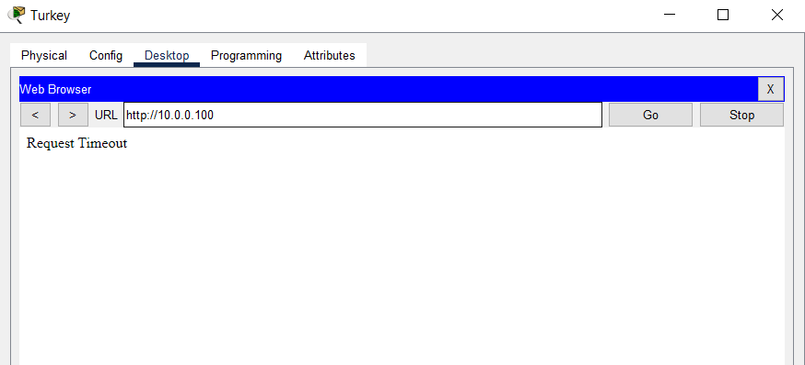

AAA on the Irbid Router.

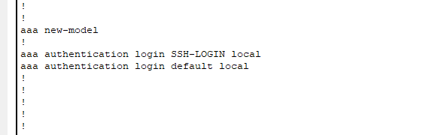

DMZ set for the Aqaba network

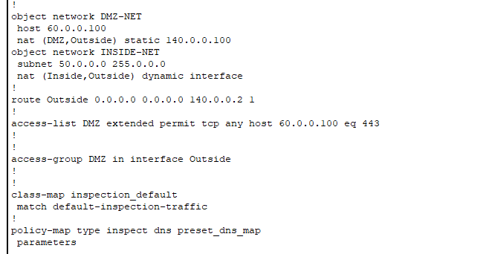

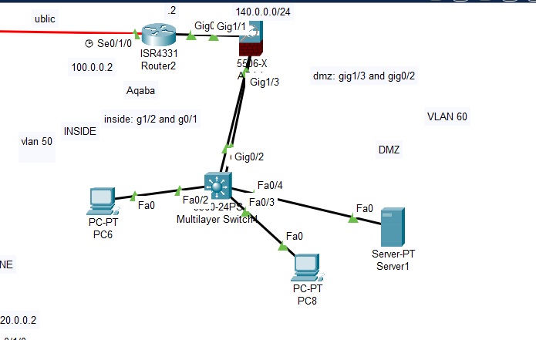

3. Critical Evaluation and Improvement Recommendations:

After completing the testing phase, a critical evaluation of the network's design, planning, configuration, and testing should be conducted. This evaluation involves assessing the effectiveness of the implemented security measures and identifying areas for improvement.

a. Design Evaluation: Review the network's design to identify any potential flaws or weaknesses that could compromise security. Ensure that the design aligns with best practices and addresses the specific security requirements of JNR.

b. Planning Evaluation: Assess the adequacy of the planning process, including the consideration of security measures and the incorporation of industry standards and guidelines. Evaluate if the planning phase effectively addressed the network's security requirements.

c. Configuration Evaluation: Carefully review the configuration of network devices, such as firewalls, routers, switches, and gateways. Verify that they are correctly implemented and aligned with the organization's security policies. Identify any misconfigurations or vulnerabilities that need to be addressed.

d. Testing Evaluation: Analyze the test results and compare them against the expected outcomes. Identify any vulnerabilities or weaknesses that were discovered during testing. Assess the effectiveness of the testing methods and whether they provided a comprehensive evaluation of the network's security.

Based on the evaluation, provide improvement recommendations to enhance the network's security posture. These recommendations could include:

- Regular Patching and Updating: Ensure that software, firmware, and security patches are regularly updated to address known vulnerabilities and protect against emerging threats.

- User Awareness Training: Implement

training programs to educate employees about best security practices, such as creating strong passwords, identifying phishing attempts, and practicing good cyber hygiene.

- Network Monitoring: Deploy robust network monitoring tools to detect and respond to any abnormal network activities or security incidents. Implementing Intrusion Detection/Prevention Systems (IDS/IPS) can provide an additional layer of security.

- Regular Audits and Assessments: Conduct periodic security audits to assess the network's compliance with security standards and regulations. Perform vulnerability assessments to identify and address any new vulnerabilities that may arise.

By implementing these improvement recommendations, the network's security can be strengthened, reducing the risk of potential security breaches and ensuring the protection of JNR's data and services.

Part 3

1. Firewalls:

Firewalls function as network security devices that oversee and regulate the flow of incoming and outgoing network traffic, utilizing predefined security rules for monitoring and control. They act as a barrier between internal networks and external networks, such as the internet, to protect against unauthorized access and potential threats. Firewalls can be hardware appliances or software-based solutions.

Types of Firewalls:a. Packet Filtering Firewalls: These firewalls scrutinize individual data packets and apply filtering mechanisms according to predetermined rules, encompassing factors such as source and destination IP addresses, port numbers, and protocols. They are generally the most basic form of firewalls.

b. Stateful Inspection Firewalls: Stateful firewalls maintain a state table to track the state of network connections. They can examine the context and history of packets to make more intelligent decisions about allowing or blocking traffic.

c. Application-Level Gateways (Proxy Firewalls): Proxy firewalls act as intermediaries between client devices and the external network. They receive network requests on behalf of clients, validate them, and then forward the requests to the destination. They provide an additional layer of security by inspecting application-level protocols.

d. Next-Generation Firewalls (NGFW): NGFWs combine traditional firewall functionalities with additional security features such as intrusion prevention, application identification and control, SSL inspection, and advanced threat protection. They provide enhanced visibility and control over network traffic.

2. Intrusion Detection Systems/Intrusion Prevention Systems (IDS/IPS):

IDS/IPS devices are designed to detect and prevent unauthorized access, malicious activities, and potential network intrusions. They monitor network traffic in real-time, analyze patterns and behaviors, and generate alerts or take active measures to block or mitigate threats.

Types of IDS/IPS:

a. Network-Based IDS/IPS (NIDS/NIPS): NIDS/NIPS devices monitor network traffic passively by analyzing packet headers, payloads, and traffic patterns. They can detect various types of attacks, including known signatures and anomalies.

b. Host-Based IDS/IPS (HIDS/HIPS): HIDS/HIPS solutions are installed directly on individual host systems to monitor and analyze system activities, including file integrity, log monitoring, and system call analysis. They provide granular visibility into host-level events.

c. Hybrid IDS/IPS: Hybrid IDS/IPS combines both network-based and host-based approaches to provide comprehensive intrusion detection and prevention capabilities. It offers a more holistic view of network security by analyzing both network traffic and host-level events.

3. Virtual Private Network (VPN) Concentrators:

VPN concentrators enable secure remote access to a private network over public networks, such as the internet. They establish encrypted tunnels between remote users and the corporate network, ensuring data confidentiality and integrity.

Types of VPN Concentrators:

a. Hardware VPN Concentrators: These are dedicated hardware devices designed specifically for handling VPN connections. They provide high-performance encryption and authentication capabilities to support a large number of concurrent VPN connections.

b. Software VPN Concentrators: Software-based VPN concentrators are virtual appliances or software applications that can be deployed on existing hardware or virtualized environments. They offer flexibility and scalability in terms of capacity and can often be integrated with other security services.

4. Network Access Control (NAC) Systems:

NAC systems regulate and control access to network resources based on the security posture of connecting devices. They enforce security policies, authenticate users and devices, and ensure compliance with security standards.

Components of NAC Systems:

a. Authentication Servers: These servers authenticate users and devices before granting network access. They can integrate with various authentication methods, such as username/password, digital certificates, or RADIUS servers.

b. Policy Servers: Policy servers define and enforce network access policies based on user

roles, device health, or other criteria. They ensure that only authorized and compliant devices can access network resources.

c. Access Enforcement Devices: Access enforcement devices, such as switches, routers, or wireless access points, work in conjunction with authentication and policy servers to enforce access control policies. They block or allow network access based on the results of authentication and policy evaluation.

5. Unified Threat Management (UTM) Appliances:

UTM appliances integrate multiple security functionalities into a single device. They typically include firewall, intrusion detection/prevention, antivirus, web filtering, VPN, and other security features, providing a comprehensive security solution.

Key Features of UTM Appliances:

a. Firewall: UTM appliances include firewall capabilities to control incoming and outgoing network traffic and protect against unauthorized access.

b. Intrusion Detection/Prevention: They offer intrusion detection and prevention functionalities to detect and block various types of attacks, including network-based threats.

c. Antivirus and Anti-malware: UTM appliances include antivirus and anti-malware scanning capabilities to identify and remove malicious software.

d. Web Filtering: They provide web filtering capabilities to restrict access to malicious or inappropriate websites, ensuring a secure web browsing experience.

e. VPN: UTM appliances often include VPN capabilities to enable secure remote access to the network.

f. Centralized Management: UTM appliances offer centralized management consoles to simplify configuration, monitoring, and reporting across the network.

Each category of devices plays a crucial role in ensuring network security, and the selection of specific devices should be based on the organization's security requirements, network architecture, scalability needs, and budget considerations.

2. Analyze the network security protocols and the application of distinct cryptographic methodologies

within the domain of network security.

1. Network Security Protocols:

Network security protocols are standardized sets of rules and procedures that ensure secure communication over networks. They provide mechanisms for confidentiality, integrity, authentication, and secure data exchange.

a. Secure Sockets Layer/Transport Layer Security (SSL/TLS): SSL/TLS protocols are widely used for secure communication over the internet. They establish encrypted connections between clients and servers, ensuring confidentiality and integrity of data. SSL/TLS protocols use cryptographic algorithms such as RSA, Diffie-Hellman, and Elliptic Curve Cryptography (ECC) for key exchange, and symmetric encryption algorithms like Advanced Encryption Standard (AES) for data encryption. Additionally, SSL/TLS includes mechanisms for server authentication, client authentication, and secure negotiation of encryption parameters.

b. Internet Protocol Security (IPsec): IPsec is a suite of protocols used to secure IP communications at the network layer. It provides confidentiality, integrity, and authentication for IP packets. IPsec can be used in two modes: Transport mode, which secures communication between two hosts, and Tunnel mode, which secures communication between networks. IPsec utilizes cryptographic algorithms such as AES, 3DES, and HMAC-SHA for encryption, integrity checking, and authentication. It also supports key exchange protocols like Internet Key Exchange (IKE) for secure establishment of shared keys.

c. Secure Shell (SSH): SSH is a cryptographic network protocol that provides secure remote access and file transfer between systems. It establishes an encrypted connection, preventing eavesdropping and unauthorized access. SSH uses public-key cryptography for key exchange and client-server authentication, ensuring secure and trusted communication. It also supports symmetric encryption algorithms like AES and 3DES for secure data transfer.

d. Secure File Transfer Protocol (SFTP): SFTP is a secure alternative to FTP (File Transfer Protocol) for transferring files over networks. It uses SSH as the underlying protocol for secure communication, ensuring data confidentiality, integrity, and authentication during file transfers. SFTP employs encryption algorithms like AES or 3DES for securing data in transit.

e. Secure Multipurpose Internet Mail Extensions (S/MIME): S/MIME is a protocol for securing email communication. It adds cryptographic capabilities to standard email protocols like SMTP (Simple Mail Transfer Protocol) and MIME (Multipurpose Internet Mail Extensions). S/MIME uses digital signatures for authentication, integrity, and non-repudiation of messages, as well as encryption algorithms for secure email content.

2. Cryptographic Methodologies:

Cryptographic methodologies involve the use of cryptographic algorithms and techniques to secure data and communications in network environments. Here are some distinct cryptographic methodologies applied in network security:

a. Symmetric Encryption: Symmetric encryption uses a single shared secret key to encrypt and decrypt data. It is fast and efficient, suitable for bulk data encryption. Well-known symmetric encryption algorithms comprise the Advanced Encryption Standard (AES), Triple Data Encryption Standard (3DES), and Rivest Cipher (RC4). Symmetric encryption is commonly used for securing data within SSL/TLS and IPsec protocols.

b. Asymmetric Encryption: Asymmetric encryption, also known as public-key encryption, uses a pair of mathematically related keys: a public key for encryption and a private key for decryption. It enables secure key exchange, digital signatures, and confidentiality. Common asymmetric encryption algorithms include RSA, Diffie-Hellman, and Elliptic Curve Cryptography (ECC). Asymmetric encryption is used for key exchange in SSL/TLS, IPsec, and SSH protocols.

c. Hash Functions: Hash functions are cryptographic algorithms that generate a fixed-size hash value from input data. They ensure data integrity by producing a unique hash for each input, making it difficult to modify data

without detection. Popular hash functions include Secure Hash Algorithm (SHA-256), Message Digest Algorithm 5 (MD5), and Secure Hash Algorithm 3 (SHA-3). Hash functions are used for message integrity checking within SSL/TLS, IPsec, and other protocols.

d. Digital Signatures: Digital signatures use asymmetric encryption to provide authenticity, integrity, and non-repudiation of digital messages or documents. They verify the identity of the signer and ensure that the signed data remains unchanged. Digital signatures are commonly implemented using algorithms such as RSA, Digital Signature Algorithm (DSA), and Elliptic Curve Digital Signature Algorithm (ECDSA). Digital signatures are used in protocols like SSL/TLS, S/MIME, and SSH for verifying the authenticity and integrity of transmitted data.

e. Key Exchange Protocols: Key exchange protocols enable secure sharing of encryption keys between communicating parties. Protocols like Diffie-Hellman (DH) and Elliptic Curve Diffie-Hellman (ECDH) use mathematical algorithms to generate a shared secret key without transmitting it over the network, ensuring secure key distribution. Key exchange protocols are utilized in SSL/TLS, IPsec, and SSH for establishing secure communication channels.

f. Secure Hash Algorithm (HMAC): HMAC is a cryptographic mechanism that combines a hash function with a secret key to provide message authentication. It ensures data integrity and verifies the authenticity of messages exchanged between network entities. HMAC is commonly used in protocols like SSL/TLS, IPsec, and S/MIME to provide message integrity and protection against tampering.

These network security protocols and cryptographic methodologies play vital roles in protecting sensitive data, ensuring secure communication, and establishing trust in network environments. Organizations leverage these protocols and cryptographic techniques based on their specific security requirements, compliance regulations, and the level of protection needed for their network communications

3. Draw comparisons and contrasts between significant network security protocols.

Certainly! Here's a detailed comparison and contrast between significant network security protocols:

1. Secure Sockets Layer/Transport Layer Security (SSL/TLS) vs. Internet Protocol Security (IPsec):

Comparison:

- SSL/TLS: Primarily used for securing communication over the internet, particularly in web browsers (HTTPS). It focuses on securing application layer protocols.

- IPsec: Designed for securing IP communications at the network layer. It can secure all IP-based traffic, including email, file transfers, and VoIP.

Contrast:

- SSL/TLS: Works at the application layer, providing encryption, authentication, and integrity for specific applications. It operates on a per-connection basis and is often used for client-server communication.

- IPsec: Works at the network layer, securing all traffic between networks or hosts. It operates at the IP packet level and can be implemented in transport mode (end-to-end encryption) or tunnel mode (encrypts the entire IP packet).

2. Secure Shell (SSH) vs. Virtual Private Network (VPN):

Comparison:

- SSH: Provides secure remote access and file transfer between systems. It is often used for securely managing remote servers and devices.

- VPN: Creates a secure tunnel over a public network, allowing remote users to access a private network securely. It provides a secure connection for remote workers or branch offices.

Contrast:

- SSH: Primarily focuses on secure remote access and secure file transfer within a single system or between trusted systems. It is commonly used for administrative purposes.

- VPN: Designed for creating secure connections between networks or individual devices over an untrusted network (e.g., the internet). It provides secure access to a private network, extending its reach to remote locations.

3. Secure File Transfer Protocol (SFTP) vs. Secure Copy Protocol (SCP):

Comparison:

- SFTP: A secure alternative to FTP for file transfer over networks. It uses SSH as the underlying protocol, providing encryption and authentication.

- SCP: A secure file transfer protocol that also uses SSH for secure copying of files between systems.

Contrast:

- SFTP: Provides a full-featured file transfer capability with features like directory listing, file management, and permissions. It is widely supported and offers better functionality compared to SCP.

- SCP: Offers a simple and straightforward file copying mechanism, limited to basic file transfer operations. It is lightweight and easy to use, suitable for quick and secure file transfers.

4. Secure Multipurpose Internet Mail Extensions (S/MIME) vs. Pretty Good Privacy (PGP):

Comparison:

- S/MIME: A protocol that adds cryptographic capabilities to email communication. It is widely supported by email clients and integrates with existing email infrastructure.

- PGP: A software program that provides email encryption and digital signatures. It operates outside the email client and requires separate installation and key management.

Contrast:

- S/MIME: Integrates seamlessly with existing email infrastructure and relies on a hierarchical trust model, where trusted Certificate Authorities issue digital certificates for email users.

- PGP: Operates independently of email clients and employs a decentralized trust model using a web of trust, where users independently validate each other's public keys.

These comparisons and contrasts highlight the differences in focus, functionality, and deployment of significant network security protocols. Organizations should choose the appropriate protocols based on their specific security requirements, infrastructure, and compatibility with existing systems.

4. Evaluate the importance of network security to an organization.

Protection of Sensitive Data: Network security measures safeguard an organization's sensitive data, including financial records, customer information, intellectual property, and trade secrets. Breaches or unauthorized access to this data can lead to severe financial losses, reputational damage, legal implications, and loss of customer trust. Implementing robust network security controls ensures the confidentiality, integrity, and availability of sensitive data.

Prevention of Data Breaches: Data breaches have become increasingly common and can have devastating consequences for organizations. Network security measures, such as firewalls, intrusion detection systems (IDS), and data encryption, help prevent unauthorized access to networks and systems. By implementing comprehensive security measures, organizations can significantly reduce the risk of data breaches and mitigate potential damages.

Safeguarding Business Continuity: A network security breach can disrupt an organization's operations, resulting in downtime, loss of productivity, and financial losses. Network security measures, including backup and recovery systems, disaster recovery plans, and network monitoring, help ensure business continuity by minimizing the impact of security incidents and enabling prompt recovery from potential disruptions.

Protection against Malware and Cyber Attacks: Malware, viruses, ransomware, and other cyber threats pose significant risks to organizations. Network security solutions, such as antivirus software, intrusion prevention systems (IPS), and advanced threat detection tools, help detect, prevent, and mitigate the impact of these attacks. By continuously monitoring network traffic and employing robust security measures, organizations can stay protected against evolving cyber threats.

Compliance with Regulatory Requirements: Many industries are subject to regulatory requirements regarding the protection of sensitive data, such as financial information (e.g., PCI-DSS for payment card data) or personal data (e.g., GDPR for European Union citizens' data). Network security measures help organizations meet these compliance obligations by implementing appropriate security controls, maintaining data privacy, and demonstrating compliance to regulatory authorities.

Protection of Reputation and Customer Trust: A security breach can significantly damage an organization's reputation and erode customer trust. Organizations that prioritize network security demonstrate their commitment to protecting customer data and maintaining the privacy and confidentiality of sensitive information. This, in turn, enhances customer trust, strengthens brand reputation, and provides a competitive edge in the market.

Prevention of Intellectual Property Theft: Intellectual property (IP) is a valuable asset for organizations. Network security measures help protect intellectual property from unauthorized access, theft, or misuse. By implementing secure networks, access controls, and encryption mechanisms, organizations can safeguard their IP, innovative ideas, research, and proprietary information.

Mitigation of Financial Losses: The financial implications of a network security breach can be substantial. Organizations may incur expenses related to incident response, forensic investigations, legal actions, customer compensation, and remediation efforts. Investing in robust network security measures and proactive risk management can help mitigate these potential financial losses.

5. Determine which network hardware and software to use in the network. Justify your choices.

this my choice "

Router: A router is a fundamental networking device that connects multiple networks and routes data packets between them. It functions within the network layer (Layer 3) of the OSI model. Routers analyze network addresses and determine the best path for data transmission. They provide connectivity, enable network segmentation, and facilitate efficient data routing across different networks.

Switch: A switch is a networking device that functions at the data link layer (Layer 2) of the OSI model. It connects devices within a local area network (LAN) and enables communication between them. Switches forward data packets based on MAC addresses, improving network performance by reducing unnecessary network traffic and enabling efficient data transmission.

Multilayer Switch: A multilayer switch combines the functionalities of both a router and a switch. It operates at multiple layers of the OSI model, including Layer 2 switching and Layer 3 routing. Multilayer switches provide enhanced performance and flexibility by enabling both local network communication (switching) and inter-network communication (routing) within a single device.

Firewall (ASA): A firewall is a crucial network security device that monitors and controls incoming and outgoing network traffic based on predefined security rules. Cisco ASA (Adaptive Security Appliance) is a popular firewall solution that provides advanced security features such as access control, intrusion prevention, VPN termination, and threat detection and prevention.

Layer 3 Switch: A layer 3 switch combines the functionalities of a switch and a router at Layer 3 of the OSI model. It performs routing functions internally and can route traffic between VLANs (Virtual Local Area Networks) within the switch itself. Layer 3 switches offer faster routing performance compared to traditional routers and provide improved network scalability and flexibility.

Layer 2 Switch: A layer 2 switch operates at the data link layer (Layer 2) of the OSI model. It provides high-speed switching between devices within a local network. Layer 2 switches use MAC addresses to forward data packets, improving network performance and reducing network congestion. They are essential for creating LANs and segmenting networks.

SSH (Secure Shell): SSH is a cryptographic network protocol that provides secure remote access and secure file transfer between systems. It establishes an encrypted connection, preventing eavesdropping and unauthorized access. SSH is commonly used for secure administration of network devices, such as routers, switches, and servers.

OSPF (Open Shortest Path First): OSPF is a dynamic routing protocol used to determine the best path for data transmission within an IP network. It calculates the shortest path based on network topology and dynamically adjusts routes in response to network changes. OSPF enhances network scalability, efficiency, and fault tolerance by facilitating faster and more reliable routing.

VPN (Virtual Private Network): VPNs create secure and encrypted connections over public networks, such as the internet. They allow remote users to access a private network securely, providing privacy, data confidentiality, and secure remote communication. VPNs are crucial for remote workers, branch offices, and ensuring secure communication between geographically distributed networks.

DHCP (Dynamic Host Configuration Protocol): DHCP is a network management protocol that dynamically assigns IP addresses to devices within a network. It simplifies network administration by automating IP address configuration, subnet mask assignment, gateway addresses, and DNS server information. DHCP ensures efficient IP address utilization and reduces manual configuration overhead.

VLAN (Virtual Local Area Network): VLANs are logical partitions within a physical network that allow network devices to be grouped together based on factors such as department, function, or security requirements. VLANs enhance network security, improve performance by reducing broadcast traffic, and enable flexible network management.

DMZ (Demilitarized Zone): A DMZ is a network segment that acts as a buffer zone between the internal network and the internet. It houses publicly accessible services, such as web servers, while providing an added layer of security. By isolating external-facing services in the DMZ, organizations can protect their internal network from direct exposure to potential threats.

NAT (Network Address Translation): NAT is a technique used to translate private IP addresses into public IP addresses when communicating with external networks. It allows multiple devices within a private network to share a single public IP address, enhancing network security by hiding internal IP addresses and providing a level of network address privacy.

AAA (Authentication, Authorization, and Accounting): AAA is a framework used to manage access control and authentication within a network. It ensures that only authorized users can access network resources, controls user permissions, and tracks user activities. AAA enhances network security by enforcing user authentication, authorization based on user roles, and accounting for network resource usage.

These network hardware and software choices provide essential functionalities and security measures for building a robust and secure network infrastructure. The specific selection and deployment of these components should be based on the organization's network architecture, security requirements, scalability needs, and compatibility with existing systems.

Reference list

Check Point Software. (2019). *The World’s Leading Provider of Gen V Cyber Security Solutions*. [online] Available at: https://www.checkpoint.com/.

Cloud Security Alliance. (n.d.). *Home*. [online] Available at: https://cloudsecurityalliance.org/.

CSRC Content Editor (2019). *NIST Computer Security Resource Center | CSRC*. [online] Nist.gov. Available at: https://csrc.nist.gov/.

Fortinet. (n.d.). *Fortinet | Deliver Network Security Digital Transformation*. [online] Available at: https://www.fortinet.com/.

Netacad.com. (2011). *Cisco Networking Academy Builds IT Skills & Education For Future Careers*. [online] Available at: https://www.netacad.com/.

OWASP (2023). *OWASP foundation, the open source foundation for application security*. [online] owasp.org. Available at: https://owasp.org/.

Sans.org. (2019). *Information Security Training | SANS Cyber Security Certifications & Research*. [online] Available at: https://www.sans.org/.

Us-cert.gov. (2019). *Homepage | CISA*. [online] Available at: https://www.us-cert.gov/.

www.ibm.com. (n.d.). *Enterprise Security*. [online] Available at: https://www.ibm.com/security.

www.juniper.net. (n.d.). *Juniper Networks – Global Leader in AI Networking, Cloud, and Connected Security Solutions*. [online] Available at: https://www.juniper.net/.

www.mcafee.com. (n.d.). *McAfee | Security Solutions for Cloud, Endpoint, and Antivirus*. [online] Available at: https://www.mcafee.com/.

www.microsoft.com. (n.d.). *Cloud Security Services | Microsoft Security*. [online] Available at: https://www.microsoft.com/security/ [Accessed 19 Jun. 2023].

www.nortonlifelock.com. (n.d.). *A global leader in consumer Cyber Safety | NortonLifeLock*. [online] Available at: https://www.nortonlifelock.com/.

www.paloaltonetworks.com. (n.d.). *Global Cybersecurity Leader - Palo Alto Networks*. [online] Available at: https://www.paloaltonetworks.com/.

www.trendmicro.com. (n.d.). *Trend Micro*. [online] Available at: https://www.trendmicro.com/.